Responsive Circles
Also called Conflict Resolution Circles, Repairing Harm Circles, Problem-Solving Circles…
Responsive circles are used to process and respond to a conflict, oftentimes a violation of a class agreement, school expectation, or even a law. Each circle will be unique to the circumstances and should be tailored to meet the needs of the participants.
Goals
- Students take responsibility for their role in the problem
- Students share their perspective and feelings
- Students come up with a solution and commit to what they will each do to reach the desired outcome
- The students who contributed to the problem understand the impact they caused, but keep their good name and do not feel stigmatized or shamed

Tips for a Successful Circle

- Regular, consistent use of proactive circles create a strong foundation for successful problem-solving circles
Ideally, 80% of circles should be Proactive, 20% Responsive

- Frame the purpose of the circle as problem-solving, rather than to “catch a culprit” or as punishment

- As facilitator, set the tone by being vulnerable about how the behavior impacts you

- Identify and prep a few student allies who can help the circle be successful

- Follow the Circle Agenda – Opening, Purpose, Ground rules, Prompts, Closing

- Be thoughtful about timing and location

- Include the students who want things to go well and the students who are causing disruption. Everyone is a part of the community.

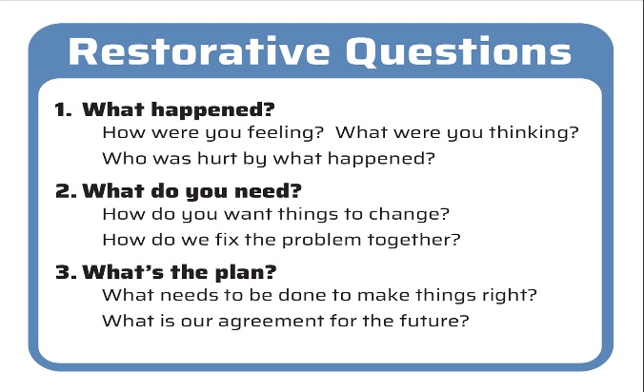
Restorative Questions
Provide a Roadmap

